Test Case: tc006_SPX_Dev5_Crear_Requisicion_Spot_Tipo_Cobro_Proyect_Urgent
Step 1 - Enter username and password and click to button Enter: Credentials Entered
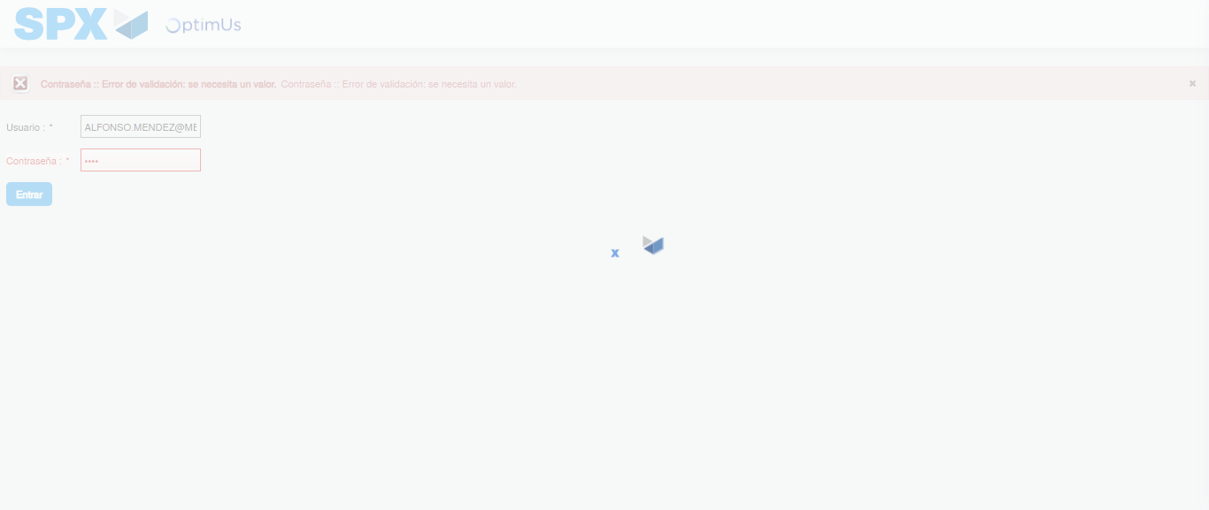Image file-name: QC_Testing-tc006_SPX_Dev5_Crear_Requisicion_Spot_Tipo_Cobro_Proyect_Urgent-1783379851302

Step 2 - Select to UEN and Access to Spot Buy Requisitions : UEN Correctly selected and Correct access
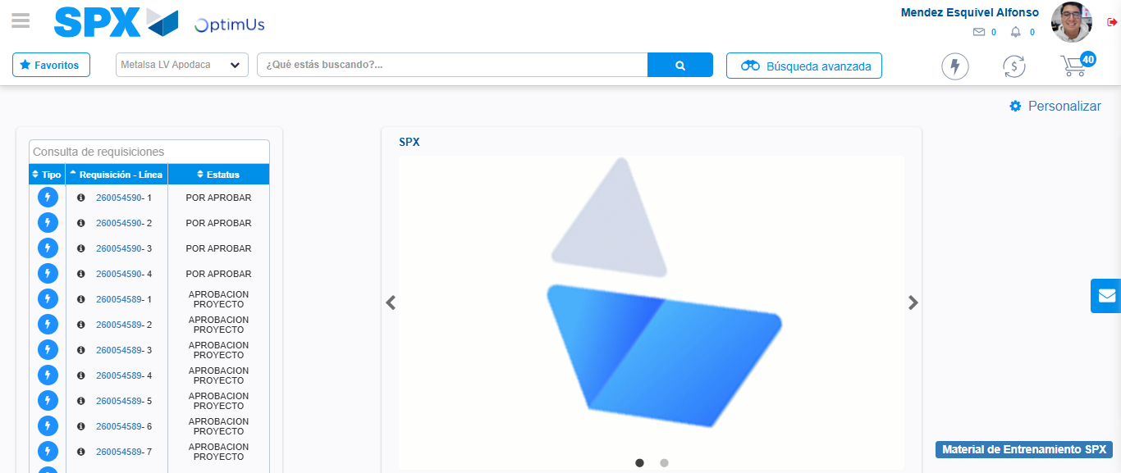Image file-name: QC_Testing-tc006_SPX_Dev5_Crear_Requisicion_Spot_Tipo_Cobro_Proyect_Urgent-1783379876665

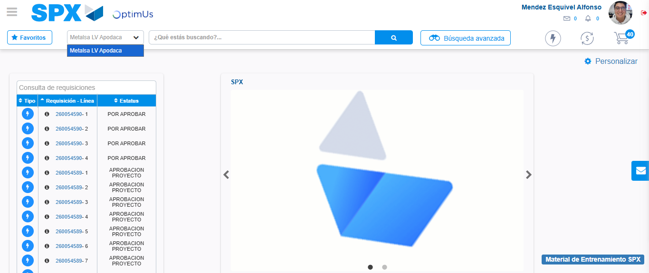Image file-name: QC_Testing-tc006_SPX_Dev5_Crear_Requisicion_Spot_Tipo_Cobro_Proyect_Urgent-1783379879149

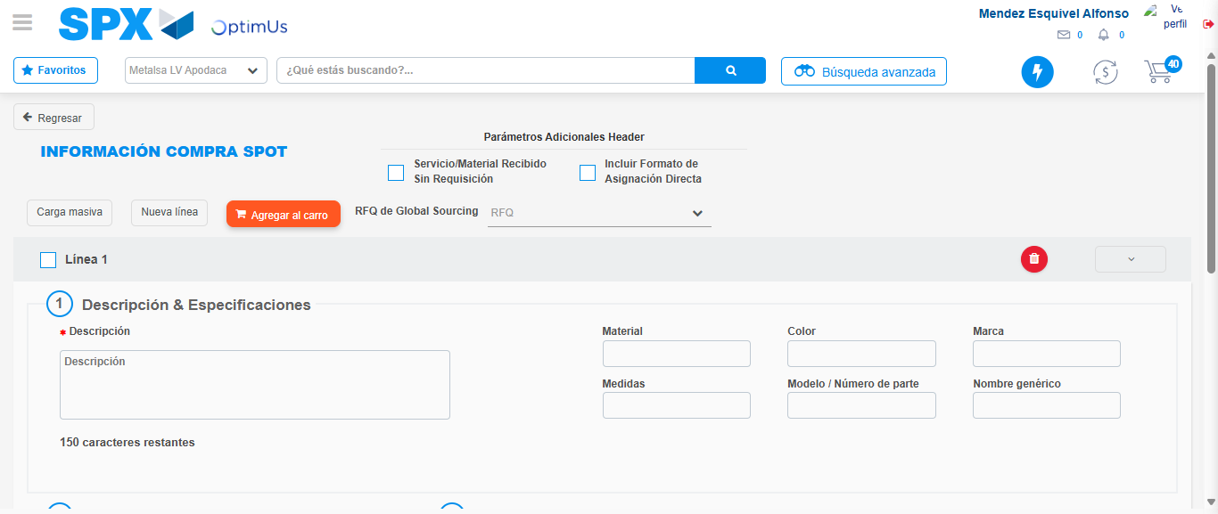Image file-name: QC_Testing-tc006_SPX_Dev5_Crear_Requisicion_Spot_Tipo_Cobro_Proyect_Urgent-1783379899246

Step 3 - Data Capture Spot Buy Requisition: Data captured correctly
Image file-name: QC_Testing-tc006_SPX_Dev5_Crear_Requisicion_Spot_Tipo_Cobro_Proyect_Urgent-1783379899472

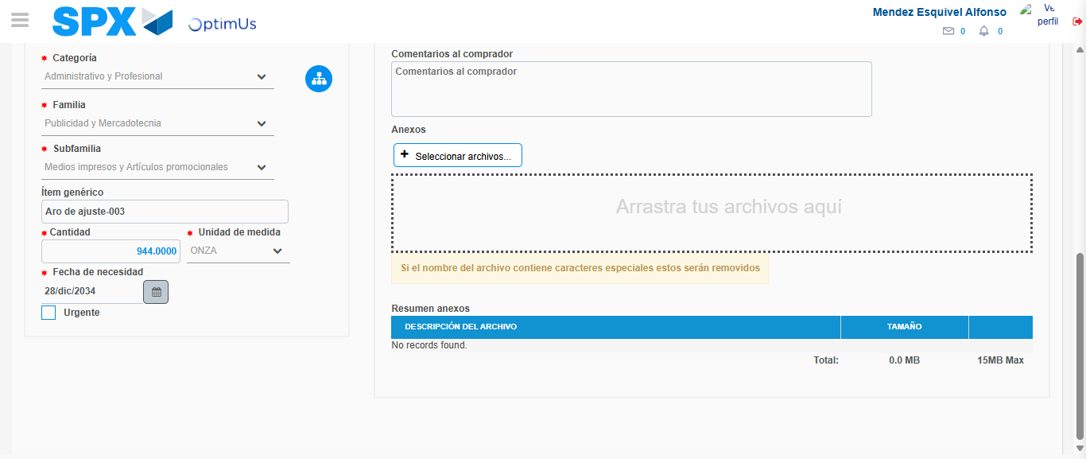Image file-name: QC_Testing-tc006_SPX_Dev5_Crear_Requisicion_Spot_Tipo_Cobro_Proyect_Urgent-1783379909691

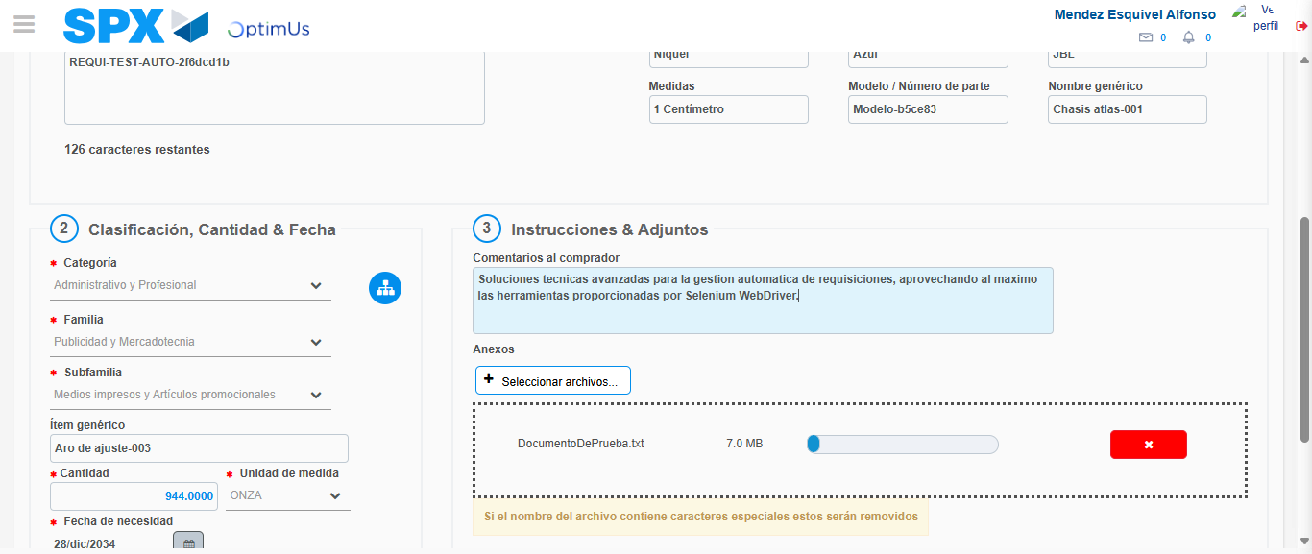Image file-name: QC_Testing-tc006_SPX_Dev5_Crear_Requisicion_Spot_Tipo_Cobro_Proyect_Urgent-1783379910478

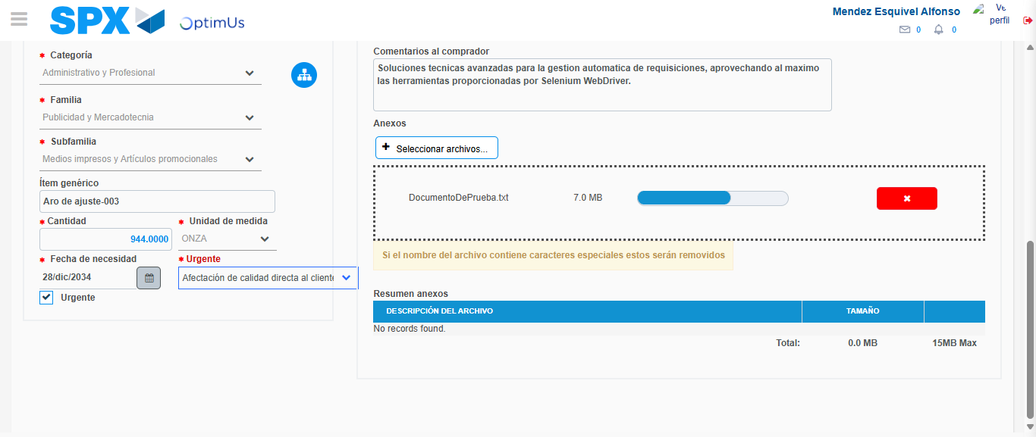Image file-name: QC_Testing-tc006_SPX_Dev5_Crear_Requisicion_Spot_Tipo_Cobro_Proyect_Urgent-1783379914084

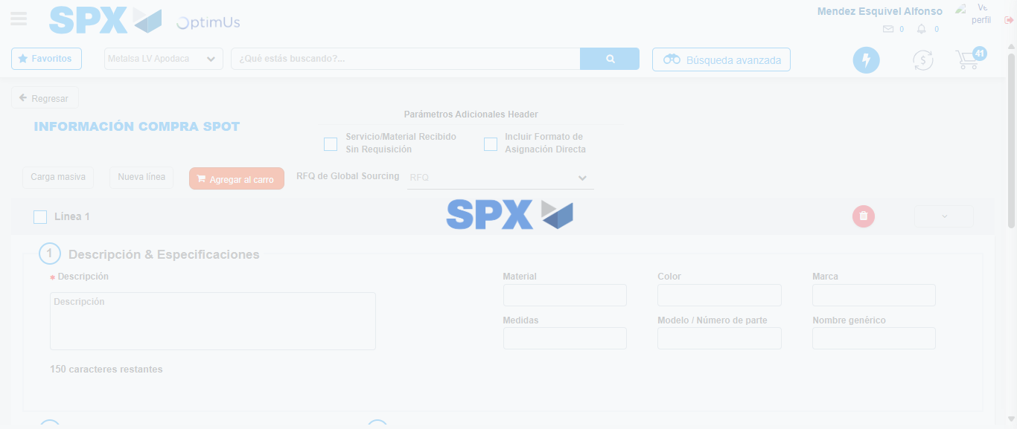Image file-name: QC_Testing-tc006_SPX_Dev5_Crear_Requisicion_Spot_Tipo_Cobro_Proyect_Urgent-1783379922032

Step 7 - Return to Main Page SPX : Return to Main Page SPX
Image file-name: QC_Testing-tc006_SPX_Dev5_Crear_Requisicion_Spot_Tipo_Cobro_Proyect_Urgent-1783379876665

Image file-name: QC_Testing-tc006_SPX_Dev5_Crear_Requisicion_Spot_Tipo_Cobro_Proyect_Urgent-1783379879149

Image file-name: QC_Testing-tc006_SPX_Dev5_Crear_Requisicion_Spot_Tipo_Cobro_Proyect_Urgent-1783379899246

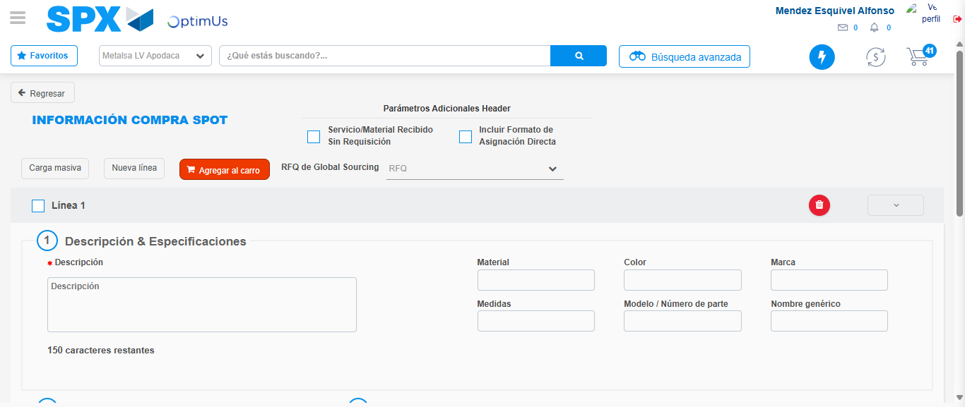Image file-name: QC_Testing-tc006_SPX_Dev5_Crear_Requisicion_Spot_Tipo_Cobro_Proyect_Urgent-1783379924280

Image file-name: QC_Testing-tc006_SPX_Dev5_Crear_Requisicion_Spot_Tipo_Cobro_Proyect_Urgent-1783379924441

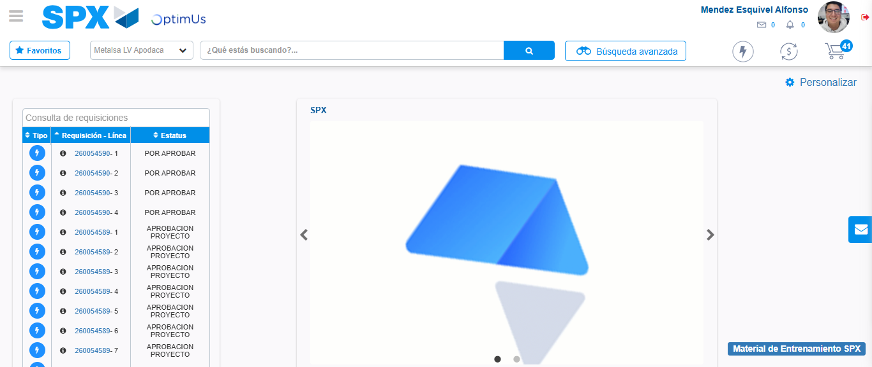Image file-name: QC_Testing-tc006_SPX_Dev5_Crear_Requisicion_Spot_Tipo_Cobro_Proyect_Urgent-1783379945607

Step 8 - Log Out : Log Out SPX
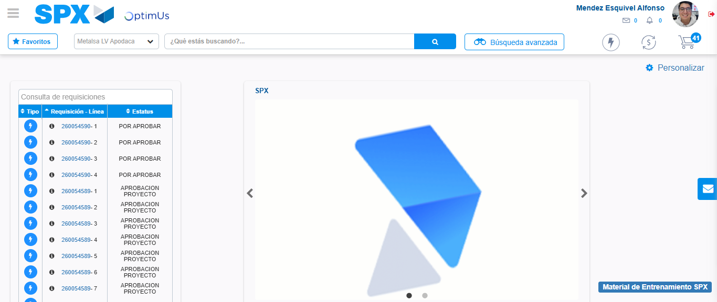Image file-name: QC_Testing-tc006_SPX_Dev5_Crear_Requisicion_Spot_Tipo_Cobro_Proyect_Urgent-1783379945847

